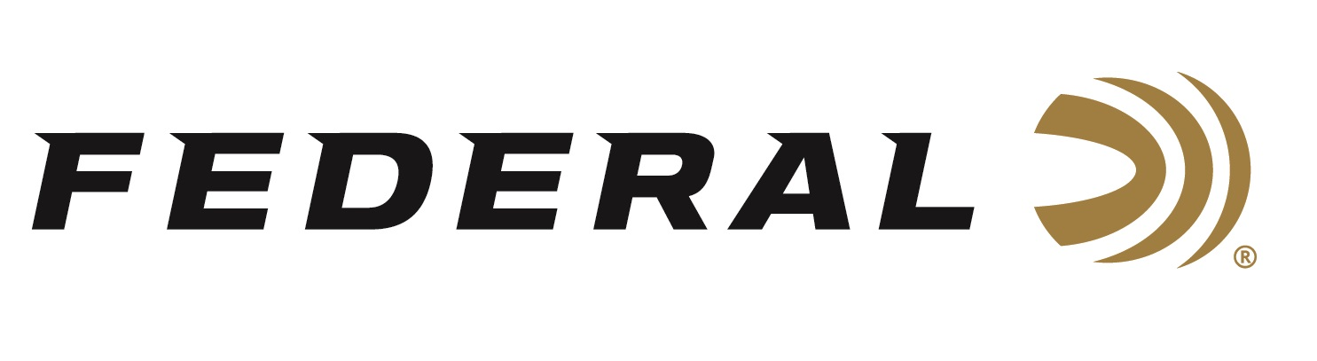

FOR IMMEDIATE RELEASE

Team Federal Claims Coveted Sporting Clay Titles

ANOKA, Minnesota – June 30, 2026 – Team Federal claimed titles at competitive sporting clay events spanning three states leading into the July 4 holiday. Two-time Olympian Derrick Mein won the Main Event at the Oklahoma State Championship, Cameron Hicks won the Main Event at the Virginia State Championship, and Gregg Wolf won Federal’s Master Class Cup held at Game Unlimited in Hudson, Wisconsin. All three events wrapped up at their respective shooting clubs on June 28, 2026.

“Team Federal had a great showing this weekend,” says Federal’s VP of Marketing Jason Nash. “With the World FITASC, U.S. Open and North Central Regional on the horizon, the team is fine-tuning its skills for an exciting stretch of competitions,” said Nash.

Derrick Mein won the Oklahoma State Championship Main Event, sponsored by Federal Ammunition, by defeating a field of more than 250 shooters at Snake Creek Shooting Sports in Beggs, Oklahoma. Mein secured the title by six targets over the second-place finisher. Cameron Hicks was equally impressive with his victory at the Virginia State Championship, besting a field of 231 shooters with a four-target advantage over the runner-up in the Main Event at the Brushy Mountain Club in Hurt, Virginia. Gregg Wolf headed east from his home state of Minnesota to claim Federal’s Master Class Cup at Game Unlimited in Hudson, Wisconsin. Wolf won the Cup title by a three-target margin.

Federal Ammunition products, including the new Master Class, are available at dealers nationwide and online. This competition-level sporting clay load features a customized Podium wad that extracts peak performance from utilizing Federal’s straight-wall hull, reliable primers, high-antimony lead shot, and select propellant. For more information on Master Class and all Federal products, visit www.federalpremium.com.

Federal Ammunition products are available at dealers nationwide and online. For more information on all Federal products and to sign up to receive notifications about new product availability, rebate promotions, and other brand news via email, visit www.federalpremium.com.

Press Release Contact: JJ Reich
Senior Manager – Press Relations
E-mail: media@tkghunt.com

About Federal Ammunition
Federal, headquartered in Anoka, MN, is an ammunition brand of The Kinetic Group, owned by CSG, a globally diversified industrial group based in Prague, Czech Republic. Since 1922, Federal has been a leader in ammunition innovation, delivering high-quality sporting and hunting products to shooters worldwide. With a commitment to conservation and the outdoor community, Federal continues to manufacture industry-leading ammunition that enhances the shooting experience while supporting outdoor traditions.

